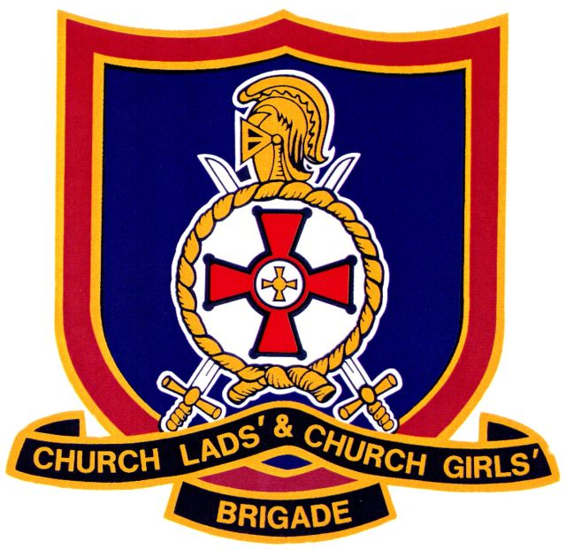

**The CLCGB Annual General Meeting**

The Annual General Meeting of The Church Lads’ and Church Girls’ Brigade, is to be held at St David’s Church Hall, Greenhill Road, Coalville, Leicester, LE67 4RL

On Saturday 22nd November 20.14 at 11.00am

**Proposed Agenda:**

1. Opening Prayer.
2. Governors Welcome and Opening Remarks.
3. Apologies for absence:
4. To approve the minutes of the last AGM
5. Matters arising from the Minutes.
6. Annual Reports
7. To receive the Governors Report
8. To Receive the Chief Executives Report
9. To receive the Financial Report
10. To receive the Training Officers Report
11. To receive the FTOG Report
12. To receive the Youth Forum Report
13. Brigade Council Elections
14. Strategy
15. Any Other Business.
16. Date and venue of next AGM
17. Closing Prayer.

Break for Lunch

Afternoon Workshop Sessions

Chief Executive Presentation on suggested new structure

Martyn Bedder Presentation on Highwood 2016

The meeting will finish no later than 3pm.